Project 1
My Favorite Movies

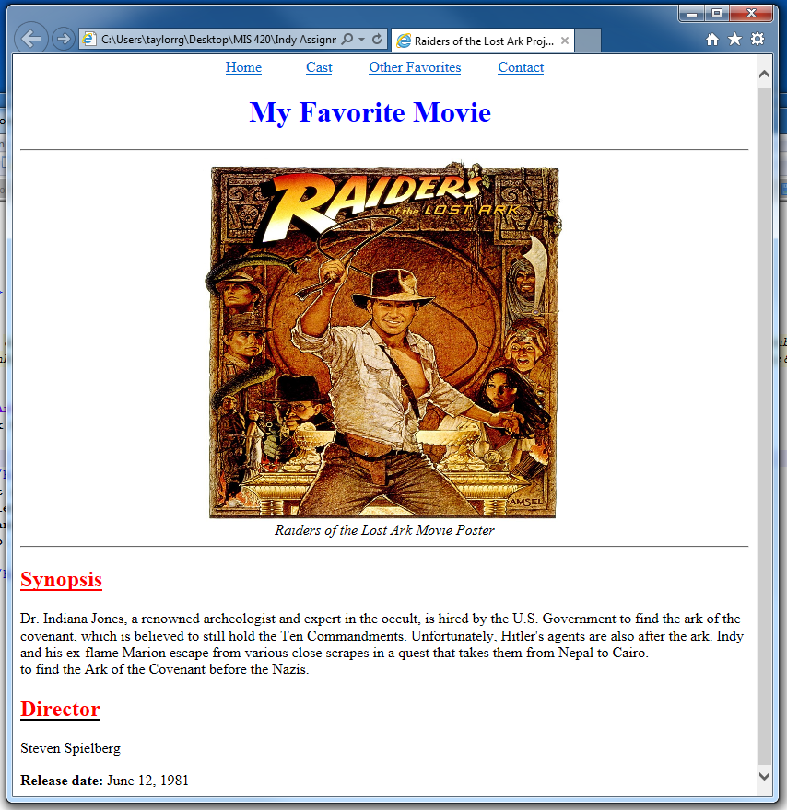

See: www.imdb.com for information about movies
Cast Page should be like your Disney Characters Page (with the same types of links). So there will be links to the top 5 characters in the movie (with an individual page for each cast member).
Other Favorites should be like your Attractions/Locations page. Include the movie posters of 5 of your favorite movies….the name of the movie should link to an outside site…AND the picture (movie poster) should also link to an outside site (new tabs).
Contact: Will include your name, class, and email address with a direct link to your email address. See page 85 in your book for instructions.

Creativity is important. If you want to include video or audio Chapter 9 in your book (pg 201) will show you how. Make your page look professional.
Your pictures should be clear, not blurry. All pictures should have titles so when I scroll over a picture I will know what the picture is.
You image files should have names that are easy to understand (i.e…indianajones.jpg)
You must have one file named index….no other index files should exist in your project. No extra files in your folders…only the ones used for your site.

